**WEEK 7 SOLUTONS**

**Exercise 9:** React Application named “cricketapp”

**SOLUTION:**

**App.js:**

import React from "react";

import ListofPlayers from "./components/ListofPlayers";

import IndianPlayers from "./components/IndianPlayers";

function App() {

  const flag = false;

  return (

    <div className="App">

      <h1>🏏 Welcome to CricketApp</h1>

      {flag ? <ListofPlayers /> : <IndianPlayers />}

    </div>

  );

}

export default App;

**ListofPlayers.js**

function ListofPlayers() {

  const players = [

    { name: "Virat", score: 85 },

    { name: "Rohit", score: 45 },

    { name: "KL Rahul", score: 60 },

    { name: "Hardik", score: 72 },

    { name: "Jadeja", score: 66 },

    { name: "Shami", score: 40 },

    { name: "Bumrah", score: 95 },

    { name: "Ashwin", score: 71 },

    { name: "Dhoni", score: 90 },

    { name: "Pant", score: 55 },

    { name: "Gill", score: 78 },

  ];

  // display players

  const allPlayers = players.map((p, i) => (

    <li key={i}>

      {p.name} - {p.score}

    </li>

  ));

  // Filter players with score < 70

  const below70 = players

    .filter((p) => p.score < 70)

    .map((p, i) => (

      <li key={i}>

        {p.name} - {p.score}

      </li>

    ));

  return (

    <div>

      <h2>🏏 All Players</h2>

      <ul>{allPlayers}</ul>

      <h3>🔻 Players with Score Below 70</h3>

      <ul>{below70}</ul>

    </div>

  );

}

export default ListofPlayers;

**IndianPlayers.js**

function IndianPlayers() {

  const team = [

    "Virat", "Rohit", "Rahul", "Hardik", "Jadeja", "Shami", "Bumrah", "Ashwin", "Dhoni", "Pant", "Gill",

  ];

  // Destructuring Odd & Even Team Players

  const oddTeam = team.filter((_, i) => i % 2 === 0);

  const evenTeam = team.filter((_, i) => i % 2 !== 0);

  // Merge feature of ES6

  const T20players = ["Surya", "Ishan"];

  const RanjiTrophyPlayers = ["Pujara", "Rahane"];

  const allPlayers = [...T20players, ...RanjiTrophyPlayers];

  return (

    <div>

      <h2> Team Distribution</h2>

      <p>

        <strong>Odd Team:</strong> {oddTeam.join(", ")}

      </p>

      <p>

        <strong>Even Team:</strong> {evenTeam.join(", ")}

      </p>

      <h3> Merged Player List</h3>

      <p>{allPlayers.join(", ")}</p>

    </div>

  );

}

export default IndianPlayers;

**Output:**

WHEN FLAG = FALSE

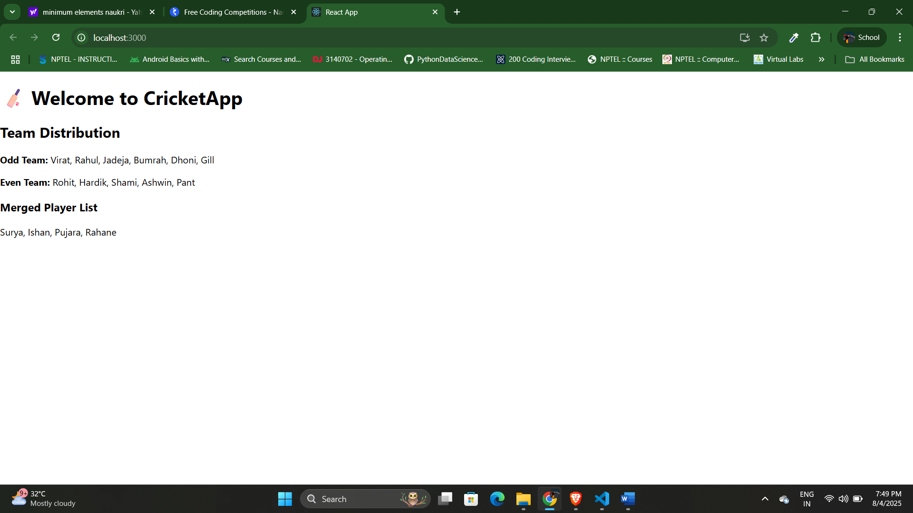

WHEN FLAG = TRUE

